Segedunum Roman Fort
Segedunum Roman Fort lay at the eastern end of Hadrian’s Wall. The fort was occupied for around 300 years. Over this time there were many changes in its plan. Most of the layout that you see here shows the fort plan as it was in about AD 200, when it was garrisoned by a cohort of 480 infantry and 120 cavalry soldiers.

Cobbles mark the lines of the walls. Golden gravel is used to show building interiors. Streets between the buildings are represented by pebbles.

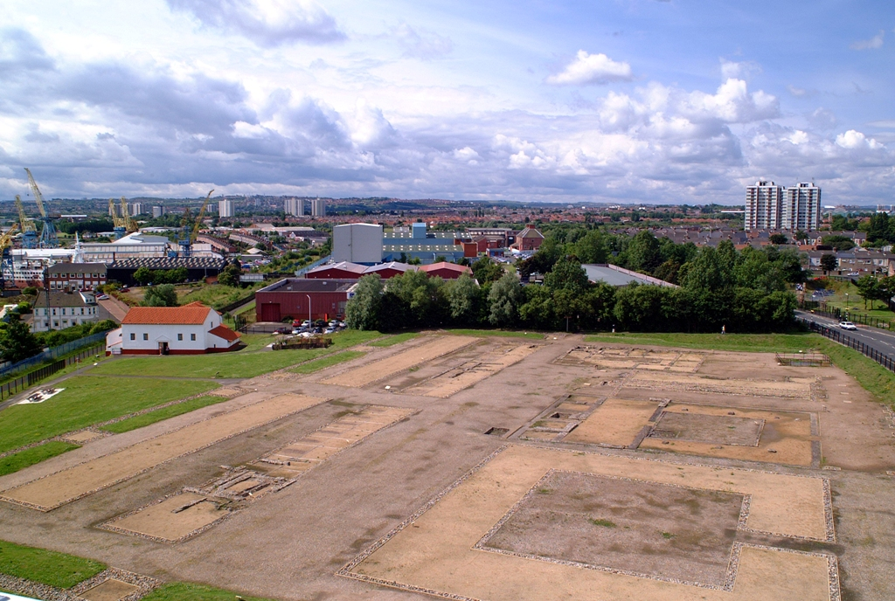
Head Quarters Buildings
South Gate
Granaries
Hospital
Reconstructed Bath House
Cavalry Barracks
Commanding Officer’s House
View of the fort from the viewing tower.

The Men Who Built the Wall
This inscription gives the names of Roman soldiers known to have taken part in the building of Hadrian’s Wall. The names come from ‘centurial stones’ which were set up by the work gangs recording the section of wall they worked on. They name the officer (centurion) in charge of each section.

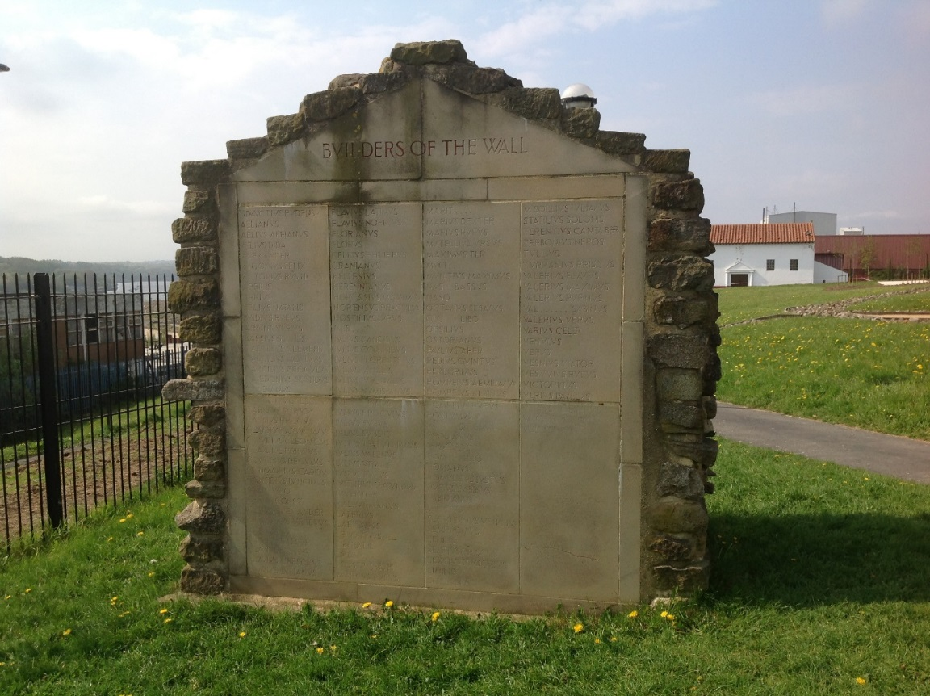

The Branch Wall
This section of Hadrian’s Wall is part of the ‘Branch Wall’, the section of Hadrian’s Wall that runs from the south-east corner of the fort down to the river, forming the ‘Wall’s End’.

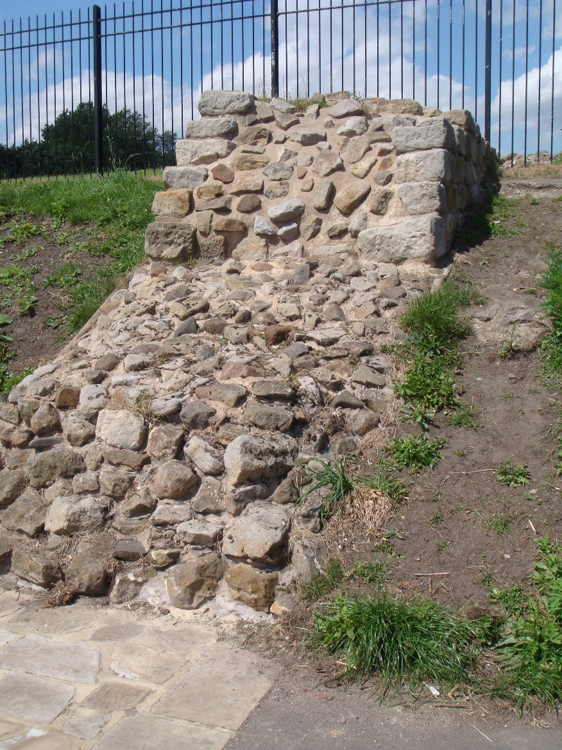

Baths Reconstruction
This bath house is based on the remains of the bath house at Chesters Fort on Hadrian’s Wall. This is not the original site of the baths at Segedunum. The baths were rediscovered in 2014 about 100m south of this spot.
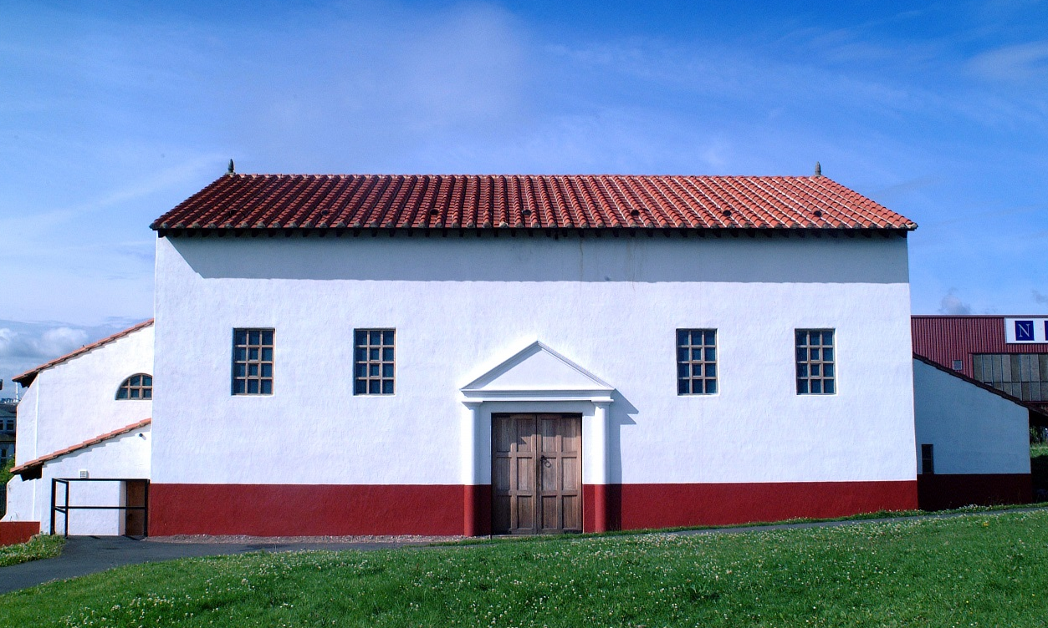

South Gate
For much of its life this gateway formed the main exit to the civilian settlement (vicus) outside the fort on the bank of the river. Outside the gate there was a system of defensive ditches.
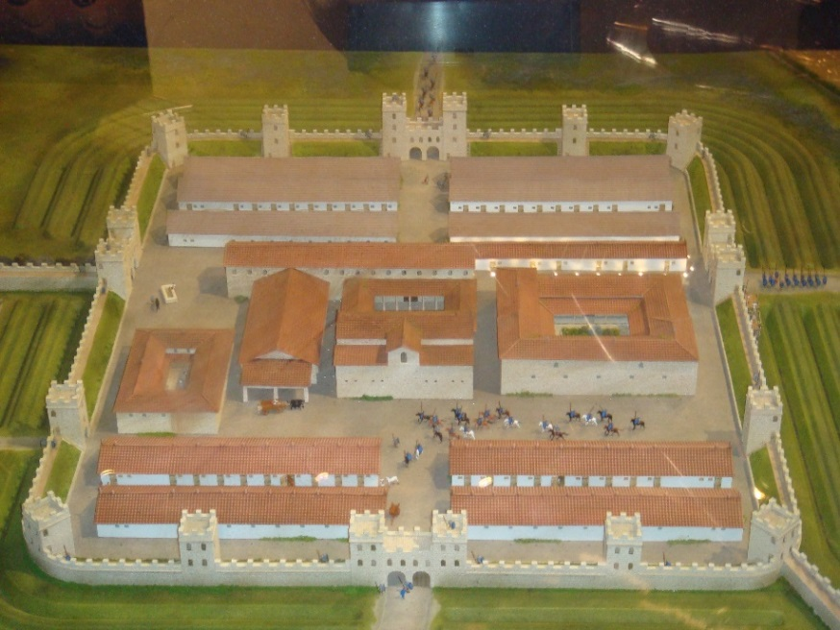
South Gate facing the river

Cavalry Barrack
These barracks housed the four troops of cavalry at Segedunum. Each space was divided into a front room and back room. Each back room housed three soldiers. Their horses were kept in the front rooms. At one end of the block was a house for the officer in charge of the cavalry troop. He was called the Decurion.

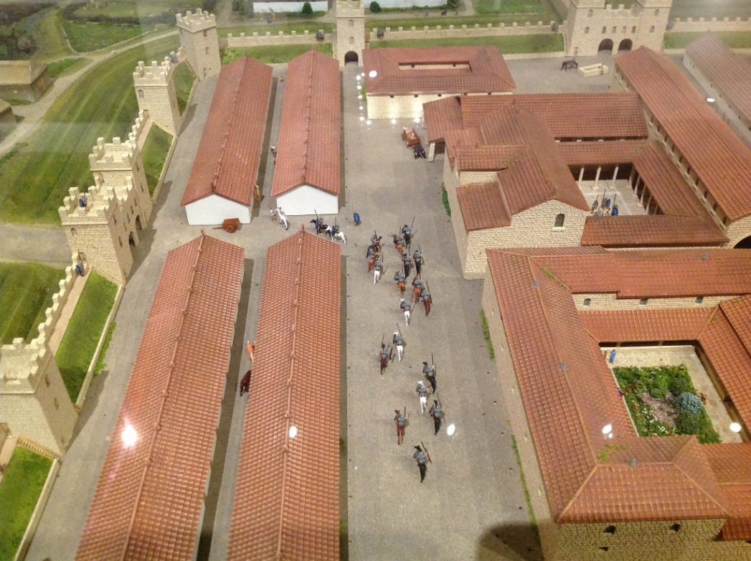
Four long, cavalry barrack buildings can be seen to the left of this model of the fort.

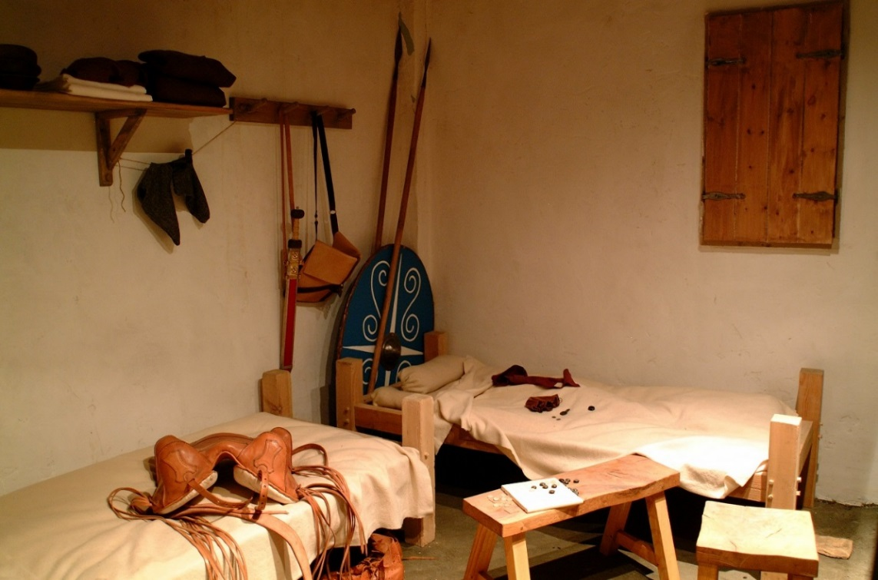
Reconstruction of a cavalry barrack room inside the Roman Gallery
The Minor West Gate
(porta Quintana sinistra)
This was a simple gate with a single entrance and would have had a tower above it: it became the main way into the fort. A small building attached to one side of the gate tower may have functioned as a guard house.

Hospital
(Valetudinarium)
There have been no finds from this building which prove that it was a hospital, but there are clues to suggest it was. We know that some other Roman forts contained hospitals, and that the Roman army had a staff of doctors. In one corner of this building is a large latrine (lavatory), a feature found in hospitals in other forts. This suggests that the building was used by many people living together, and was not a house for a single officer.

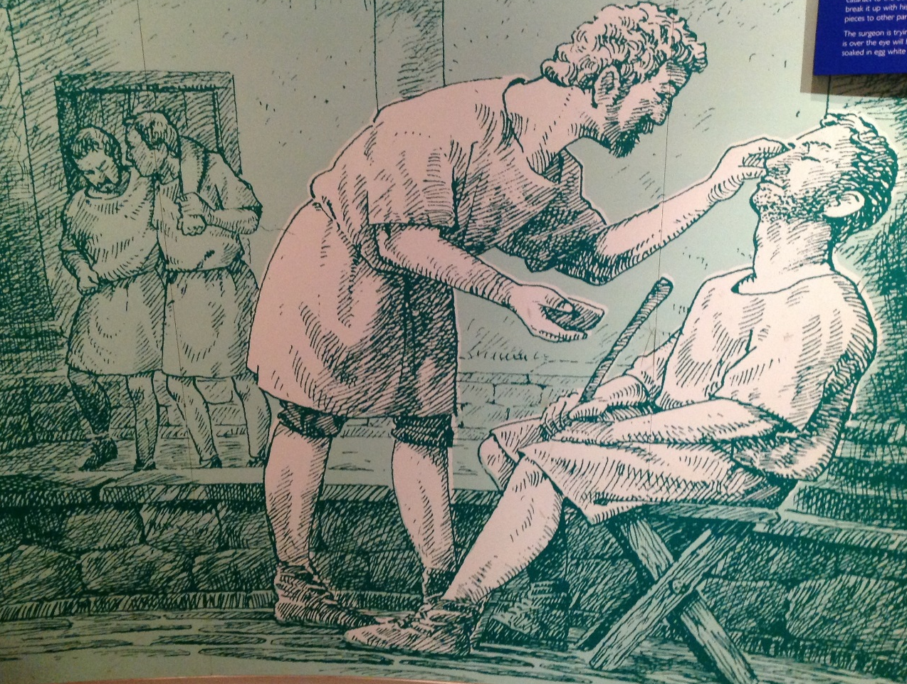
Illustration of an eye operation inside the Roman Gallery

How did the latrine work?
The latrine would have had stone seats over the deep channels which can now be seen in the room. Waste falling into these channels was flushed away by water arriving through drains.

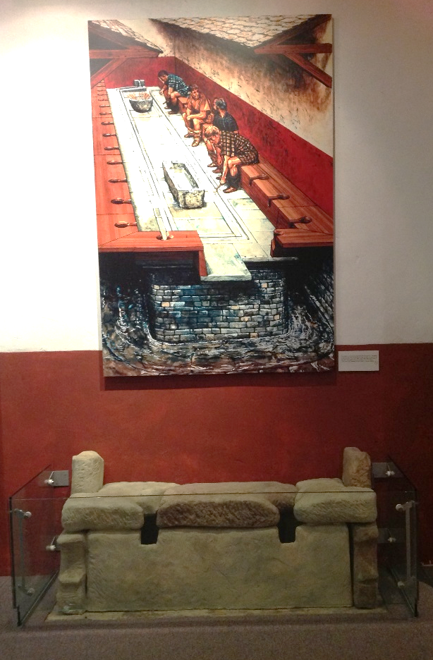
Reconstruction of the toilet incorporating the original seat found in the hospital building.

Water Tank
Water storage tanks were common in Roman forts. They were filled with rainwater or sometimes with water from outside springs using aqueducts. The Romans were careful to make sure each fort had a good water supply and Segedunum would also have needed much water for horses. A drain ran south from this tank to flush the lavatories in the hospital.

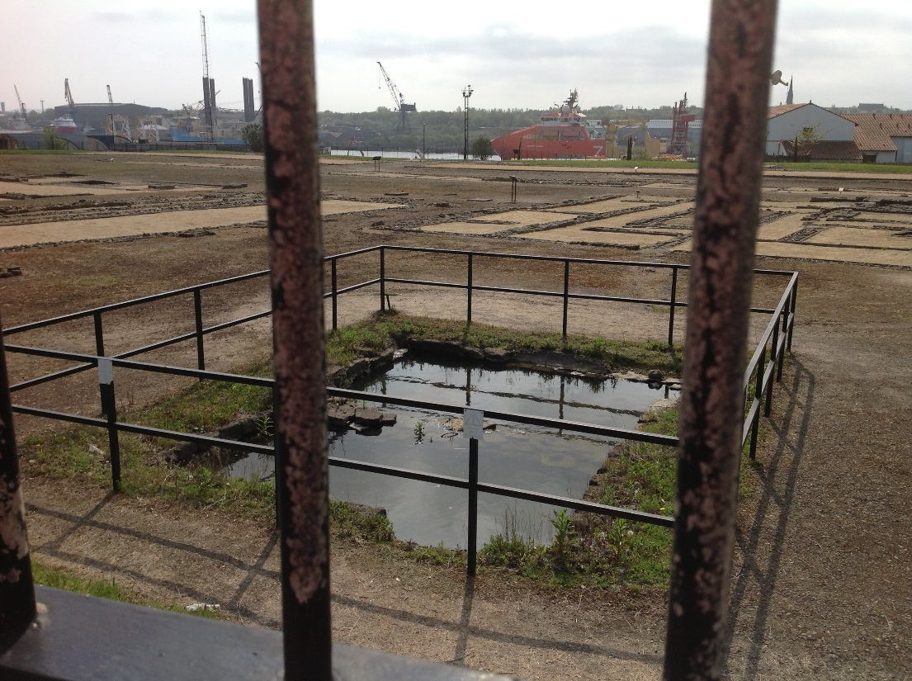

Forehall
The forehall was a tall building which ran across the front of the headquarters building and the granary. Archaeologists do not know exactly what these buildings were for. It was once thought that they may have been drill halls for soldiers to train in bad weather. However, it is now believed that they may have been used for religious and ceremonial gatherings.

Granaries
(Horrea)
This building was used to store supplies for the garrison of Segedunum, especially grain and other perishable foodstuffs. Every fort had a granary or granaries: this building is two granaries joined together.
One half of this building has a series of parallel wall foundations. These were for rows of walls which supported a raised floor, to keep the grain dry and prevent rodents getting in to eat the food.
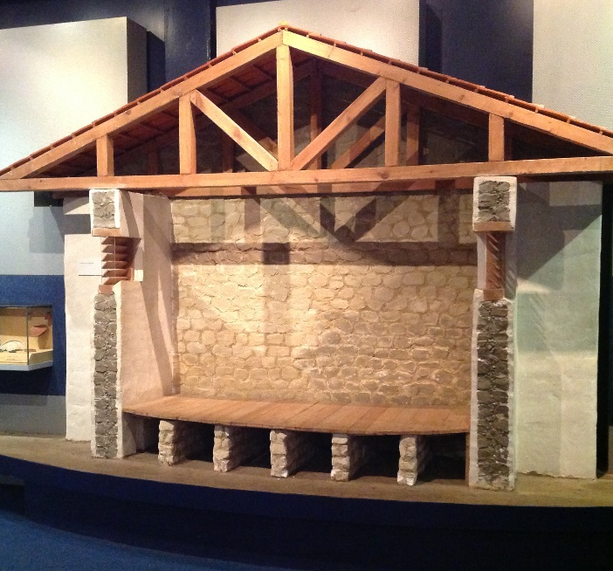
Model to show construction of the granary building with raised floors, inside the Roman Gallery
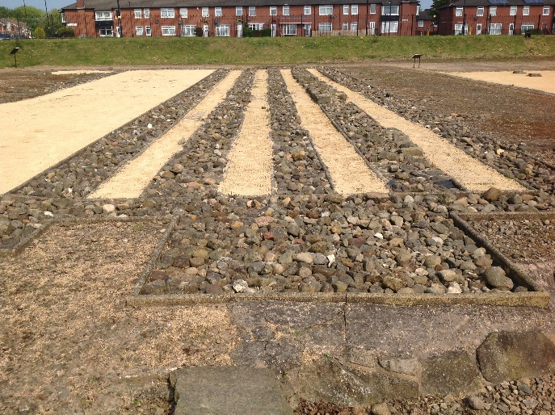

The Headquarters
(Principia)
Headquarters buildings were made up of a courtyard, a great hall and a row of five rooms. The outer walls of the building would have been whitewashed and the roof covered with bright red tiles.
What went on inside the headquarters?
Religious ceremonies and sacrifices took place in the open courtyard. The great hall would have been a large church-like structure full of groups of soldiers going about their business. In the centre of the rooms behind the great hall an underground chamber or strong room is visible. This was used for safeguarding sacks of coins used to pay the soldiers. Above the strong room would have been a shrine to the gods, which would also contain the battle standards of the unit in garrison. The pairs of rooms on either side of the central shrine were offices used by pay clerks.

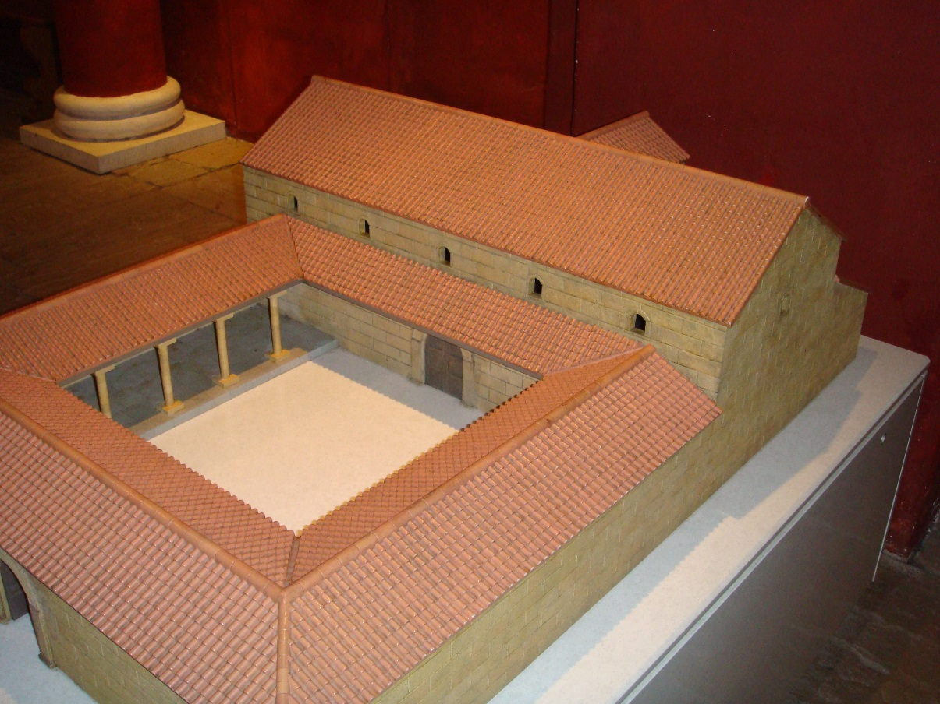
Model of the Headquarters building inside the Roman Gallery

The Commanding Officer’s House
(Praetorium)
This was the largest building in the fort, reflecting the high social status of the unit commander. He was an aristocrat from the Mediterranean area, sometimes even from Italy itself. His house was exactly like rich Roman houses in Mediterranean cities.
The central courtyard was designed to provide shade from the Mediterranean sun, but is found even here at Wallsend. Around the courtyard were dining rooms, kitchens, living rooms, libraries and studies, bedrooms, stables and baths. The wife and children of the commanding officer would have lived here, as well as an extensive household of slaves.

View of ‘C’ shaped Commanding Officer’s House from the viewing tower

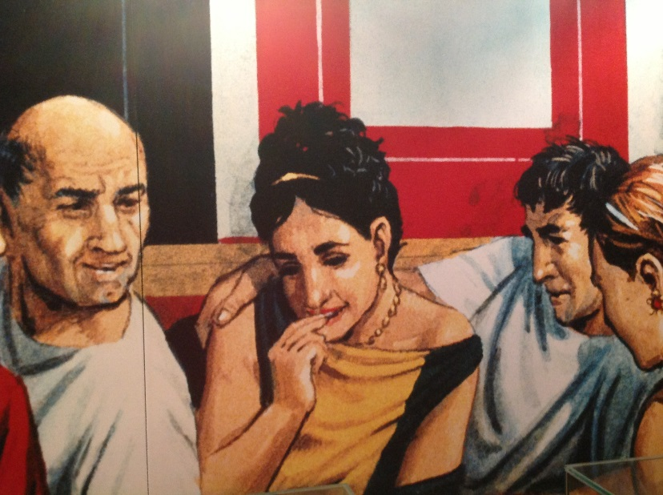
Illustration of the Commanding Officer’s House
Hadrian’s Wall
The stones which you see are the surviving remains of Hadrian’s Wall, built in about AD 124. The ditch which ran 6m in front of the wall is not visible. The oak posts mark the position of a series of obstacles which could be entangled with sharpened branches to form a barrier- an ancient form of barbed wire.
To the south of the Wall remains is a reconstruction based on the available evidence for the appearance of Hadrian’s Wall in Roman times. It is likely that the wall had a walkway and battlements like this but this still has to be proven.
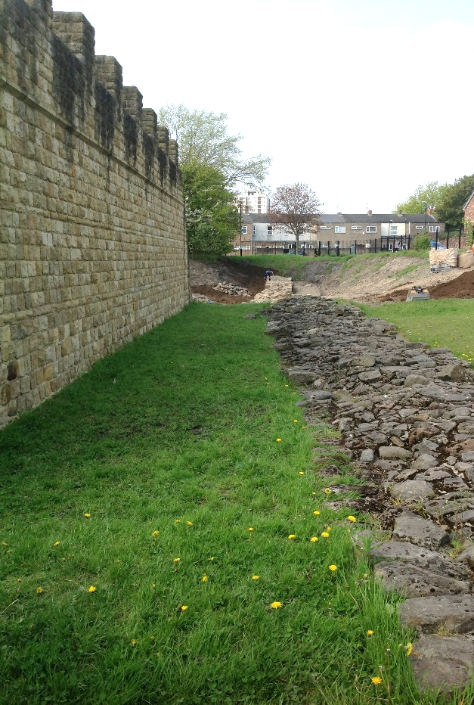
Hadrian’s Wall remains and reconstruction

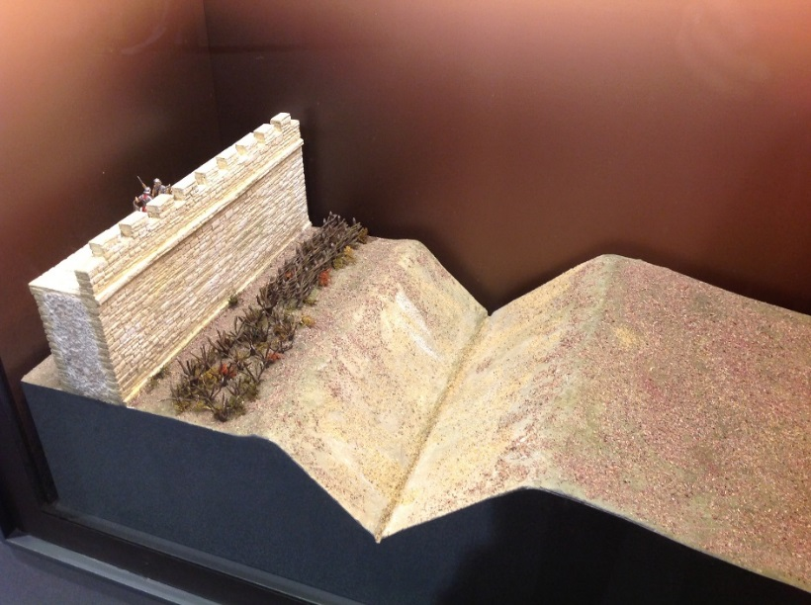
Model of Hadrian’s Wall inside Roman Gallery

